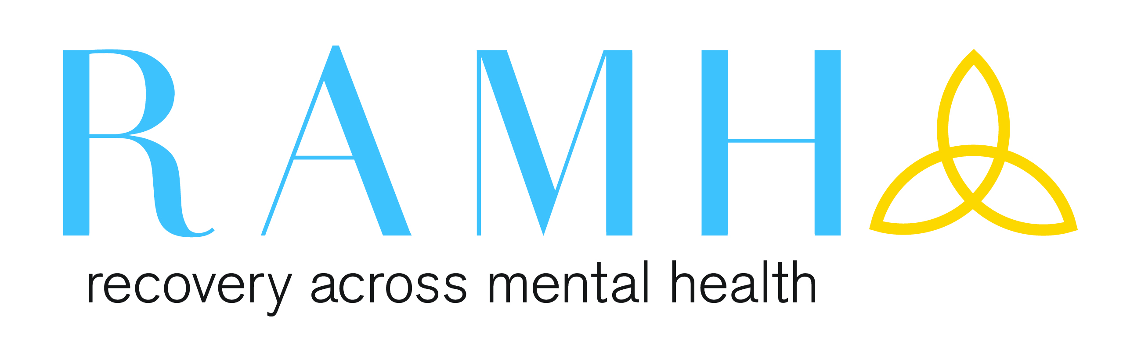
Job Description

Job Title: Community Connector

Responsible to: Causeway Service Manager

Hours: 22.5 hours weekly – to be worked as the Service requires (1 x twilight shift a week)

Location: East Renfrewshire

Salary: SP27 – SP 30 £23,090 - £25,562 per annum

Pension: 6% of basic salary – 2% employee contribution
(plus 2 x salary life insurance benefit)

Travel Expenses: 45p per mile

Job Summary:

Working as part of a team you will liaise closely with individuals and families from assessment, through to delivery of 1-1 brief interventions or with time limited group work. You will be involved in liaising with statutory, voluntary, RAMH and user-led services to link clients to appropriate support networks within the local area. You will encourage people to develop and explore self-management approaches, as part of the individual’s recovery journey.
The main focus of your work will be telephone assessments, one to one case load work, and or group work. Both group and one to one are delivered using a brief model normally 4 - 6 weeks, which are delivered in the project base or in community venues and at times we may use digital platforms.

Responsibilities:

- To be aware of and implement the RAMH philosophy.

- To support and encourage new approaches to self-management as part of someone’s Recovery journey. Building support pathways that link into the East Renfrewshire community.

- To carry out assessments mainly on the telephone.

- To carry a caseload that delivers brief one to one interventions, or, group work, looking at - anxiety management, self-esteem, sleep hygiene and any other areas of self-management.

- Work alongside RAMH and partner community services in East Renfrewshire to develop understanding of RAMH Community services.

- Liaise with internal and external agencies to publicise the services and to generate appropriate referrals.

- To keep clear and accurate records of all interventions carried out and record on Nebula.

- To identify and maintain a database / record of available activities, resources and support networks for people to access.

- To utilise appropriate electronic database recording systems

- To implement quality monitoring and service evaluation systems, as identified by the funders, to enable reporting on outcomes.

- To attend team meetings and participate in supervision as required.

- To carry out any other duties as delegated by the line manager.

- To adhere to RAMH policies and procedures and SSSC (Scottish Social Services Council) Code of Practice

Scottish Social Services Council Registration:

- All staff must be aware of timescales and requirements of registration with SSSC – Scottish Social Services Council.

- Staff who are registered must take personal responsibility of making themselves aware of the requirements of registration and adhere to these requirements.

- It is NOT the responsibility of RAMH to register staff.

- Staff who are required to register with SSSC and don’t complete registration within the timescales set out, will NOT be able to be employed in their current role, until registration is completed. This means that there may be no employment opportunities for staff in RAMH, if they are not registered.

- Failure to register within timescales will result in disciplinary action and may result in suspension without pay or dismissal from RAMH.

The foregoing job description is not exhaustive and other tasks may be associated with this position as directed. The post-holder will be expected to participate in the on-going development of the post
Person Specification
Community Connector - East Renfrewshire
22.5 hours weekly

EXPERIENCE

Essential Desirable
Experience in mental health, wellbeing or equivalent | ✓
A minimum or equivalent of SVQ 3 | ✓
Experience of the impact of long term conditions and an understanding of recovery or self-management approaches | ✓
Experience of prompting empowerment and self-direction in support of recovery and self-management | ✓
Experience of assessment and carrying a caseload | ✓
Carry a caseload, working in a short term model
Experience of writing reports which includes outcomes and activities |  | ✓
Experience of reviewing and evaluation |  | ✓
Experience of working closely with health and social care professionals | ✓
Experience of utilising community facilities as a resource | ✓
Experience of working with groups |  | ✓

SKILLS
Ability to work as part of a team | ✓
Ability to working at a fast pace, delivering brief interventions i.e. anxiety management | ✓
Ability to maintain confidential records and statistical information on service use for the purposes of evaluation | ✓
Ability to self-evaluate and reflect on practice | ✓
Ability to produce written reports as necessary | ✓
Good IT skills | ✓
Organisational skills | ✓
An ability to work in the Community independently across the East Renfrewshire area, including travelling | ✓

PERSONAL TRAITS

Ability to communicate effectively with a range of health and social care professionals, service users and Carers | ✓
Ability to motivate and inspire others | ✓

ADDITIONAL JOB REQUIREMENTS

Able to work flexible hours (twilight shift) | ✓

