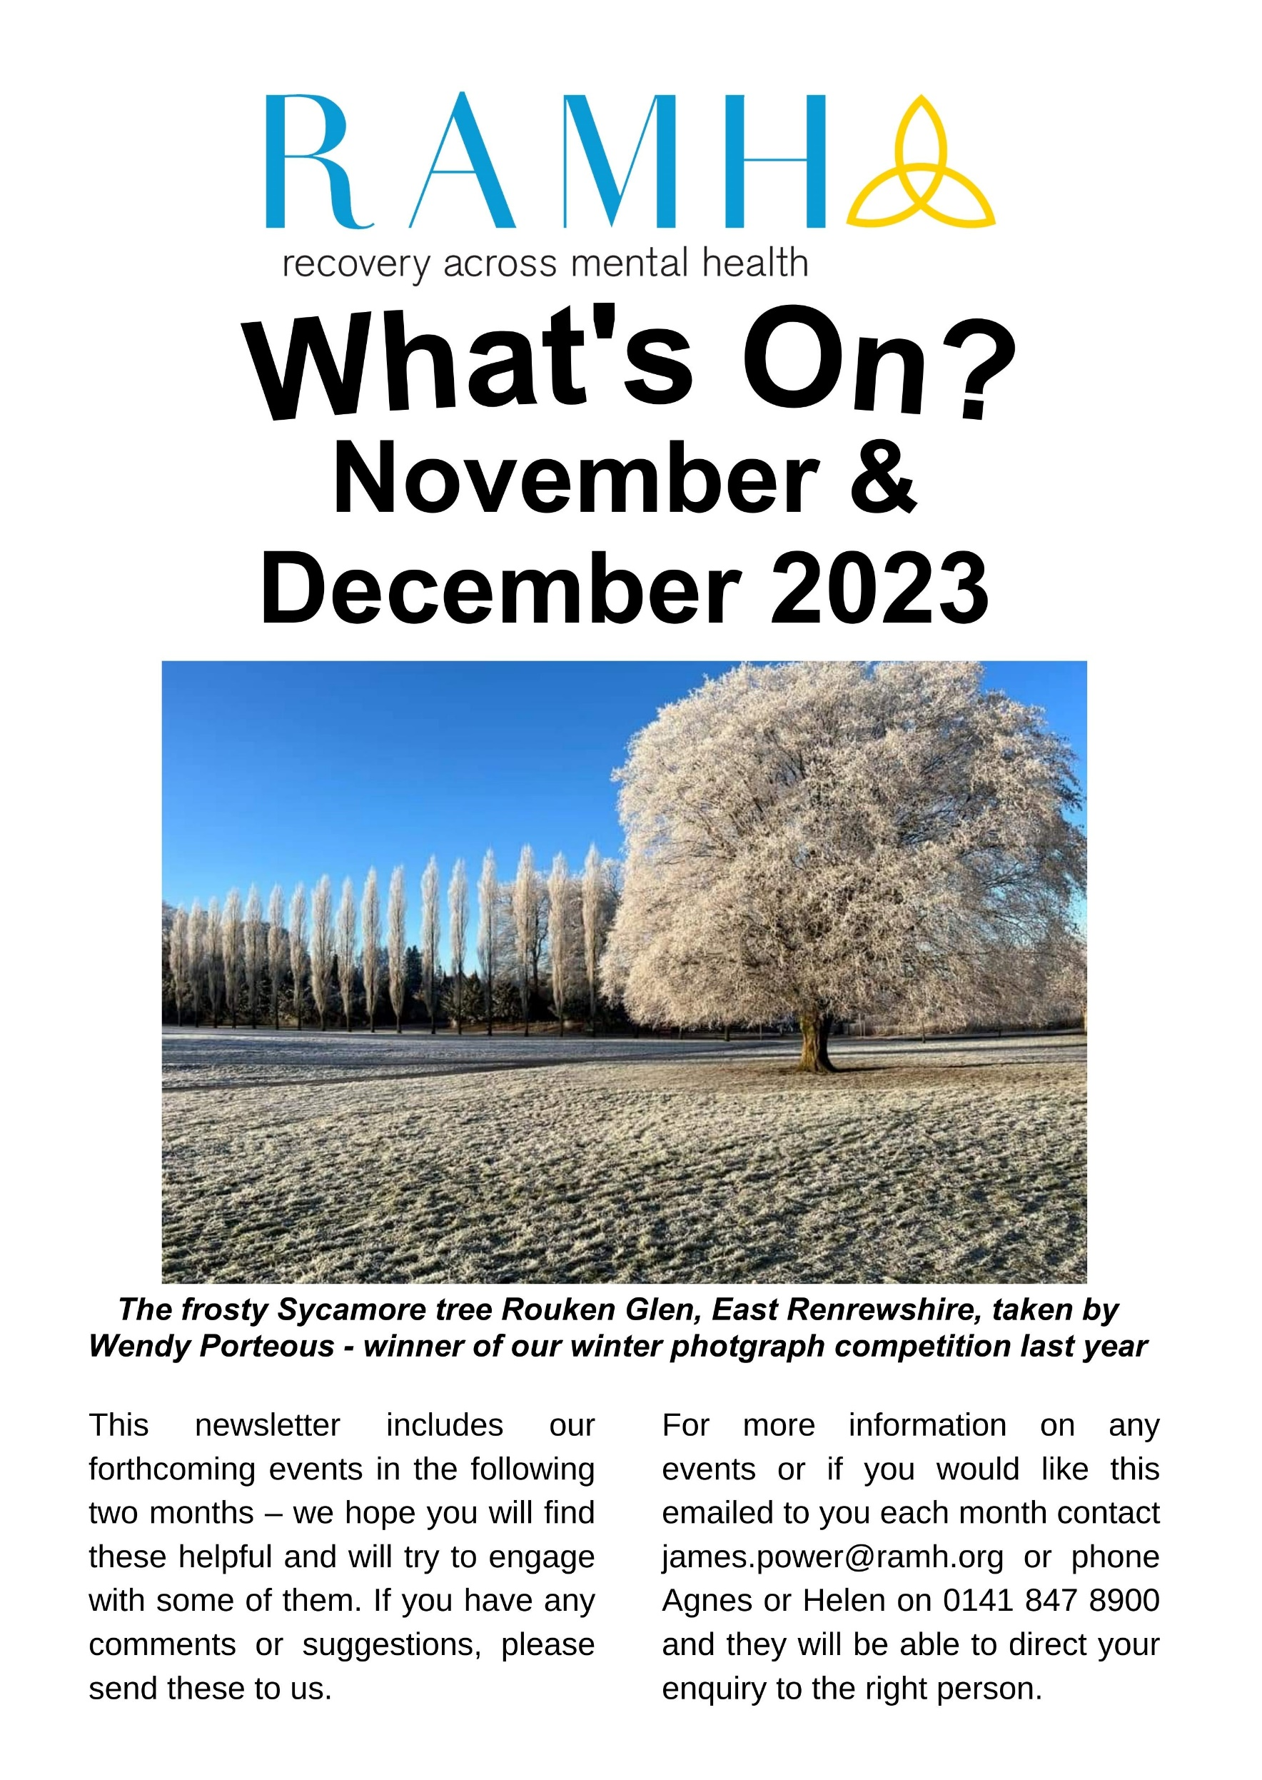

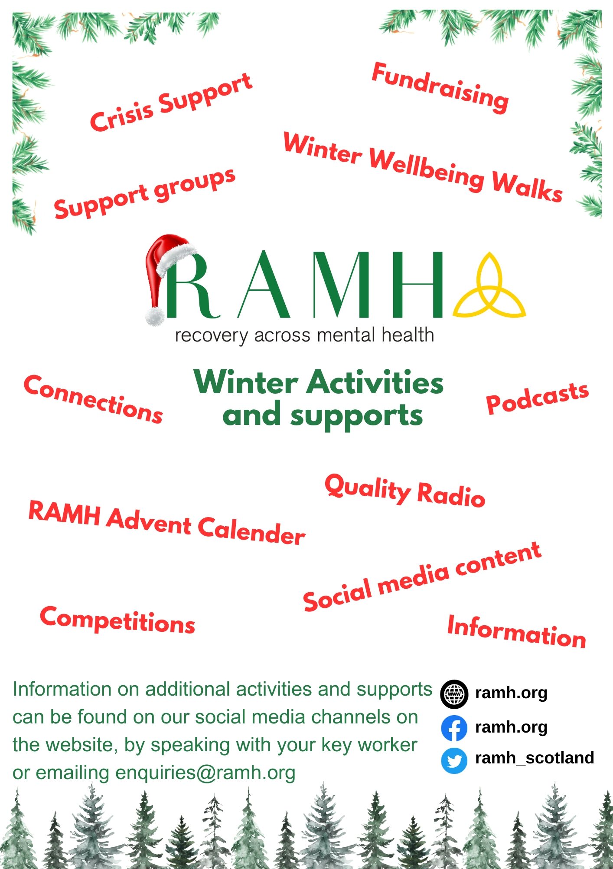

Renfrewshire Services

To make a referral, please call 0141 404 7788 or fill out a referral form on ramh.org For more information please email enquiries@ramh.org

First Crisis  Freephone: 0800 221 8929  Or Tel: 0141 848 9090 for information  Available Monday– Friday 9am- 8pm  And Saturdays and Sundays 9am-5pm | Out of hours crisis service which provides a short-term support to anyone in Renfrewshire aged 16 or over, experiencing a crisis in their mental health
Appointments across the week
1:1 Counselling | *Counselling waiting list in Renfrewshire is  currently closed*
Employability Support | RAMH is a mental health employability provider  We offer one-to-one and group support services for individuals facing mental health struggles due to work, those seeking employment or volunteer opportunities, and those in education.
Anxiety Management; 1:1 and group | Support for individuals who are struggling to control their anxiety and to help people to understand why they become anxious; how their thinking affects their anxiety which in turn affects how people behave and aims to improve their ability to control their anxiety.
1:1 Graded Exposure Support | This is a short-term intervention of 6 sessions to support individuals' challenge and overcome their anxiety through practice i.e., travelling independently. Develops and encourages systematic practice of either new or lost skills aimed at reducing anxiety.
Mondays
Wellbeing Miles | Robertson Park Renfrew 11.30 -12pm (Meeting at the Pond)  Walking a mile is a great way to introduce activity to your week and connect with others
Renfrewshire Social Hub  Renfrew Trinity Hall  12.30-14.00 | Renfrewshire Social Hub is a mixed group pf men & women who get together for Peer-to-Peer support. We make up a six-week program of varied activities. We are a warm welcoming group to help reduce isolation and increase your confidence and have a laugh along the way which will improve your mental wellbeing.
Singing for Wellbeing  Renfrew Trinity Hall  15.00-16.30 | A warm and friendly group who like to sing and have some fun along the way. No previous experience needed just a love of music and singing along. The group looks to improve your mental wellbeing.
Tuesdays
Wellbeing Miles | Team up to Clean up - Venues tbc  Walking a mile is a great way to introduce activity to your week and connect with others
Contact Plus  Paisley Methodist Hall  18.00-20.00 | The contact Plus is a mixed group of people who get together for Peer-to-Peer support who have a varied and interesting program of activities. You will be warmly welcomed in the group it will make you more socially connected and increase your self-esteem.
Wednesday
Wellbeing Miles | Barshaw Park 1.30-2.30pm (meet at the front gate)  Walking a mile is a great way to introduce activity to your week and connect with others
Womens Group  Paisley Wynd Centre  10.30-12.00 | A safe welcoming space for women to get peer-to-peer social support and participate in various activities over a “cuppa”
WCS 1:1 Personal Training Programme | Working in partnership with the HND health and fitness students from the West of Scotland College. RAMH service users are given a 12-week gym and fitness programme, including induction, nutrition advice and 1:1 weekly gym session. The programme as part of the students course work looks to improve participants mental and physical health.
Thursdays
Taskforce  RAMH HQ  10.00-12.00 | A working party creating a greenhouse out of plastic bottles for the new garden space at headquarters.
Garden Group  RAMH HQ  10.00-12.00 | This group uses the space to be outdoors, engage in physical activity, while getting the wellbeing benefits that greenspace can offer. Once the project is finished, we will be opening this greenspace up for everyone to use to improve their mental wellbeing.
Wellbeing Miles | Johnstone 2-2.45pm (meeting at ludovic square)  Walking a mile is a great way to introduce activity to your week and connect with others.
Fridays
Nutrition with Numbers | Improve your number skills and learn in the company of likeminded people. “Nutrition with Numbers” aims to improve numeracy skills while learning the wellbeing benefits of a healthy and balanced diet.
Wellbeing Miles | Ferguslie 12-12.45pm (meet at RAMH HQ)  Walking a mile is a great way to introduce activity to your week and connect with others
1:1 Gym Support | RAMH physical activity worker supports people to be confident and competent in using the gym facility. Based centrally in Paisley at the UWS campus gym you will be given a full induction and support by the worker to develop a programme that works for you
Living Life To The Full  Paisley Wynd Centre  11.30-13.30 | A widely recognised course based on the principles of CBT (Cognitive Behaviour Therapy). The course aims to improve wellbeing and resilience, covering how to manage low mood, stress and anxiety. The course explores topics such as ‘Why do I feel so bad?’; ‘I’m not good enough’ and ‘Why does everything always go wrong?’ and more. The course is interactive, with mini booklets and encourages goal setting to guide towards making life change.
Saturdays
Football Group  Powerleague  10.30-11.30 | The group meets weekly for 7-aside games at the power league football Centre in Paisley. This group is for anyone wishing to participate in a fun friendly competitive game in a peer supportive setting.
RAMH Housing Support Services | Continues to operate 24 hours a day, every day, in Renfrewshire and East Renfrewshire providing support to people in their own homes

East Renfrewshire Services

To make a referral, please call 0141 881 8811 or fill out a referral form on ramh.org For more information please email enquiries@ramh.org
Appointments across the week
1:1 Counselling | Up to six sessions for people who experience mild to moderate depression and anxiety. Focus is on self-management skills, using self-management NHS workbooks and signposting to other services where appropriate.
1:1 Employability Support | Support for individuals aged 16 and over who are experiencing mental health problems, to focus on improving and developing their skills and experience to improve opportunities for employment.
1:1 Anxiety Management | Support for individuals who are struggling to control their anxiety and to help people to understand why they become anxious; and how it impacts physically; how their thinking affects their anxiety and the impact it has on behavior. The course aims to improve your ability to manage your anxiety.
Mondays
Men Do Talk  Dunterlie Resource Centre  10.00-12.00 | A men's peer led support group providing support and discussing issues that impact on mental health and wellbeing.
Time 2 Talk  The ARC  11.00-13.00 | A peer led recovery focused discussion group. A chance to discuss issues that are affecting your mental health and wellbeing.
Wellbeing Miles | Rouken Glen Park Eastwood 1-2pm  Walking a mile is a great way to introduce activity to your week and connect with others
Tuesdays
Exploring Recovery | Introductory course based around CHIME model of recovery.  Full of tips, techniques and strategies for getting well and staying well.
Living Life to the Full | A widely recognised course based on the principles of CBT (Cognitive Behaviour Therapy). The course aims to improve wellbeing and resilience, covering how to manage low mood, stress and anxiety. The course explores topics such as ‘Why do I feel so bad?’; ‘I’m not good enough’ and ‘Why does everything always go wrong?’ and more. The course is interactive, with mini booklets and encourages goal setting to guide towards making life change.
Swimming Group  The Foundry  10.00-11.00 | Using swimming to help increase activity, the group is supported by physical activity worker who also is in the water to give those attending motivation and confidence to participate with this hugely beneficial activity. A basic level of competency in the water is expected from those who attend.
Link Club  Dalmeny Resource Centre  13.00-15.00 | Weekly social connections group for people living in East Renfrewshire.
Wednesdays
WiRE  (Women in Recovery)  Arthurlie House  13.00-15.00 | A group supporting women in recovery to form social connections and reduce isolation within their local community.
Natural  Connections Course  Dams to Darnley  11.00-14.00 | An outdoor educational course provided by the countryside ranger in the Dams to Darnley Country park, allowing participants to learn connect and conserve in a natural greenspace
WCS 1:1 Personal Training  Programme  Starts early Decembver | Working in partnership with the HND health and fitness students from the West of Scotland College. RAMH service users are given a 12-week gym and fitness programme, including induction, nutrition advice and 1:1 weekly gym session. The programme as part of the students course work looks to improve participants mental and physical health
Thursdays
Social Support Group  Clarkston Halls  13.30-15.30 | This group meets weekly and supports people to make new social connections within their community and reduce isolation.
Wellbeing Miles | RAMH Community Garden 1-2pm  Walking a mile is a great way to introduce activity to your week and connect with others
Coping With Anxiety | For people who struggle with anxiety and similar feelings like stress and would like to improve skills to manage this and have a better understanding of how it is impacting their life.
Fridays
Wellbeing Miles | Fairweather Park Newton Mearns Fri 1-2pm  Walking a mile is a great way to introduce activity to your week and connect with others
Saturdays
Football Group  Power League Paisley  10.30-11.30 | The football group meets weekly for full contact 7-aside games at the power league football centre in Paisley. This group is for anyone wishing to participate in a fun friendly competitive game of 7 aside in a peer supportive setting.
RAMH Housing Support Services | Continues to operate 24 hours a day, every day, in Renfrewshire and East Renfrewshire providing support to people in their own homes
Community Link Services | Community link workers connect people to resources and services within their local communities with the aim of improving mental and physical health and wellbeing. Speak to your GP practice in ER for more information.
Community Garden  21 Carlibar Road, Barrhead | The garden is equipped with a number of things to help you be mindful and connect with nature. We have mindfulness cards, positivity quotes, bug hotel, heather and rose beds, 4 raised beds and ample seating. Please use the space in the best way to benefit your own mental health and wellbeing.

North Ayrshire Recovery College

If you are interested in any of the below courses or finding out more about the North Ayrshire Recovery College, please call the office on 01294 447355 or email louise.mathieson@ramh.org

Wellbeing Walks | Weekly walk in partnership with KA Leisure for physical wellbeing & building connection. This is a gentle walk suitable for all fitness levels.
Drum for Wellbeing | Join with Drum4urLife for 4 weeks of drumming fun, connecting with others and building confidence. We encourage you to give this a try: Everyone has a heartbeat so everyone can drum on a djembe drum!
Ayrshire College Health & Wellbeing | A Level 4 Health & Wellbeing Course in Partnership with Ayrshire College. Students will explore a range of health and wellbeing topics. These are aimed at raising participant’s awareness of health and wellbeing choices that can impact on life chances and opportunities. This course will assist participants in building confidence, self-awareness and provide an opportunity to develop employability skills such as working with others, planning and problem solving.
I Matter | POWWOWs are Penumbra’s workshops on wellbeing. With an informal discussion format we will share knowledge and experience.  The 5 sessions: Anxiety Matters, I Matter, Assertiveness Matters, Fitness Matters, Sleep Matters.
Peer Possibilities/Peer2Peer | The role of peer experience is fundamental to any recovery college. This introductory course will embed your understanding of your contribution as a peer within the college. We all have an individual journey and an individual story. You will meet and hear from some of our Peer Volunteer Trainers who will offer hope and inspiration for your recovery.
Exploring Recovery | A foundational course based around the CHIME recovery model exploring how Connectedness, Hope, Sense of Identity, Meaning and Empowerment can support recovery. The course includes: What is recovery? What is self-management? What can I do to get well and stay well? Full of tips, techniques and strategies and is co-facilitated by one of our Peer Volunteer Trainers who will share their personal story and experience of recovery
From Trauma to Recovery Level 2 – Zoom | Building on the learning from ‘From Trauma to Recovery’ Level 1, we reflect on what’s now better and we tackle the question of what needs to be different to let you know you are achieving your potential. Despite the serious nature of trauma participants report the course as being engaging, empowering and even fun. Both levels of this course involve short but powerful videos to support the learning. You will not be asked to share your personal experience of trauma.
Confident & Assertive | Acknowledge what makes you absolutely unique and work towards the best version of yourself by learning skills in; Communication, knowing my human rights, handling criticism well, asking for what I want, be clear about my boundaries, respect myself and respect others and work on “win/win” solutions to problems
Creative Recovery | Facilitating a creative approach to recovery exploring themes of identity. Boundaries, Inner Critic V Inner Warrior and Connecting with Self/other/nature/culture. Each workshop will involve some making or creating using different mediums to consolidate our learning. The student will be creating board game that highlights different elements of their own personal recovery.
Write to Recovery | The course generates inspiring conversations and discussions and provides an opportunity for participants to write and reflect on their own story. Each session has a different theme such as: Surviving & Thriving, What Makes Me Happy, Letter from the Wise One, Inner Critic – The Case for the Defence, Vulnerability as Power and The Hero’s Journey.

__________________________

RAMH Acumen

Light of the Distant Star

RAMH Acumen are hosting an event as part of the “To Absent Friends” Festival. Join us in celebrating the lives of those we have lost, perhaps share a poem that connects you to your loved one, and share lived experience around loss and grief. We will be making origami star
tea light holders, led by creative artist Susan Mcinnes.
At the end of the session we will sit in their light to reflect on our absent friends
This event is limited to 12 places and will be taking place in Paisley.
To register email us at
enquiries@acumennetwork.org

RAMH Caravan
The RAMH Caravan is now closed for the winter season. Thank you for everyone who booked – we hope you had a relaxing time. We are able to take bookings for Apr 24 early next year.

RAMH’s have invested in an updated, pre-loved 6 berth caravan so service users can take advantage of a low cost and fun filled short break

If you are interested in finding out more, please get in touch with Sandra on 0141 847 8900 or Sandra@ramh.org
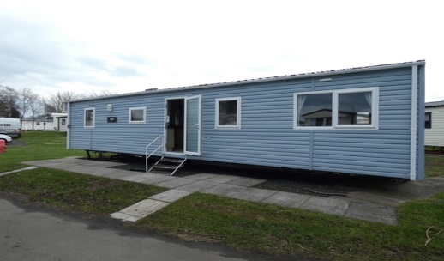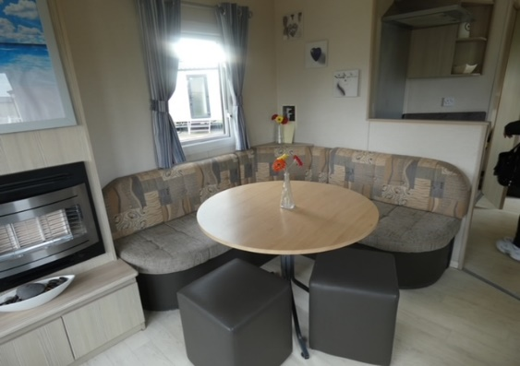

Referral form change
We have recently made a change to our referral form to make it more accessible and straightforward.

On World Mental Health Day, October 10th, we changed to an online form instead of the one you needed to download and email in before. It's a small thing but we think it will make a big difference by taking away a few steps. You will still be able to call and refer if you would prefer to do it over the phone. www.ramh.org/refer

If you live outside Renfrewshire and need immediate help, contact:

Breathing Space: 0800 83 85 87 www.breathingspace.scot
Samaritans: 116 123 www.samaritans.org
NHS 24: 111 www.nhs24.com
Text SHOUT to 85258 www.giveusashout.org

Wellbeing Maps
Where to find wellbeing in Renfrewshire and East Renfrewshire
User-led maps for anyone looking to view what mental health resources are nearby. Places on the map are categorised by: RAMH; Support service; Health centres and pharmacies; Community spaces and transport; Foodbanks and money advice; Greenspaces; Culture, leisure and sport; Employability; Religious buildings and Addictions support

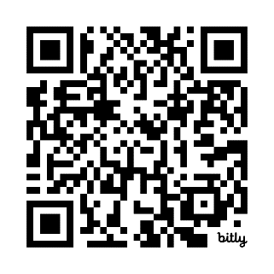
Add a location to the map yourself by emailing it to enquiries@ramh.org
East Renfrewshire
Renfrewshire

