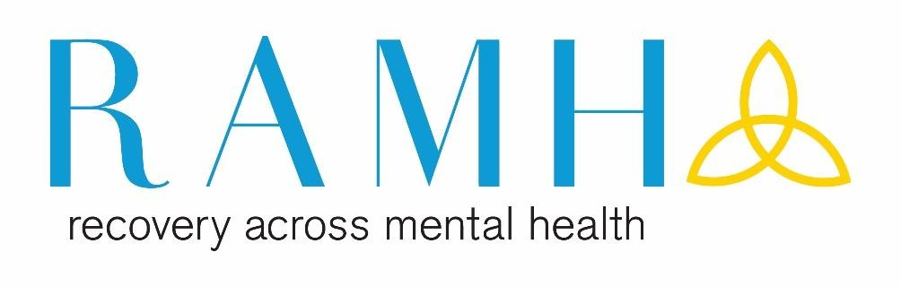

**What’s On?  
 April**

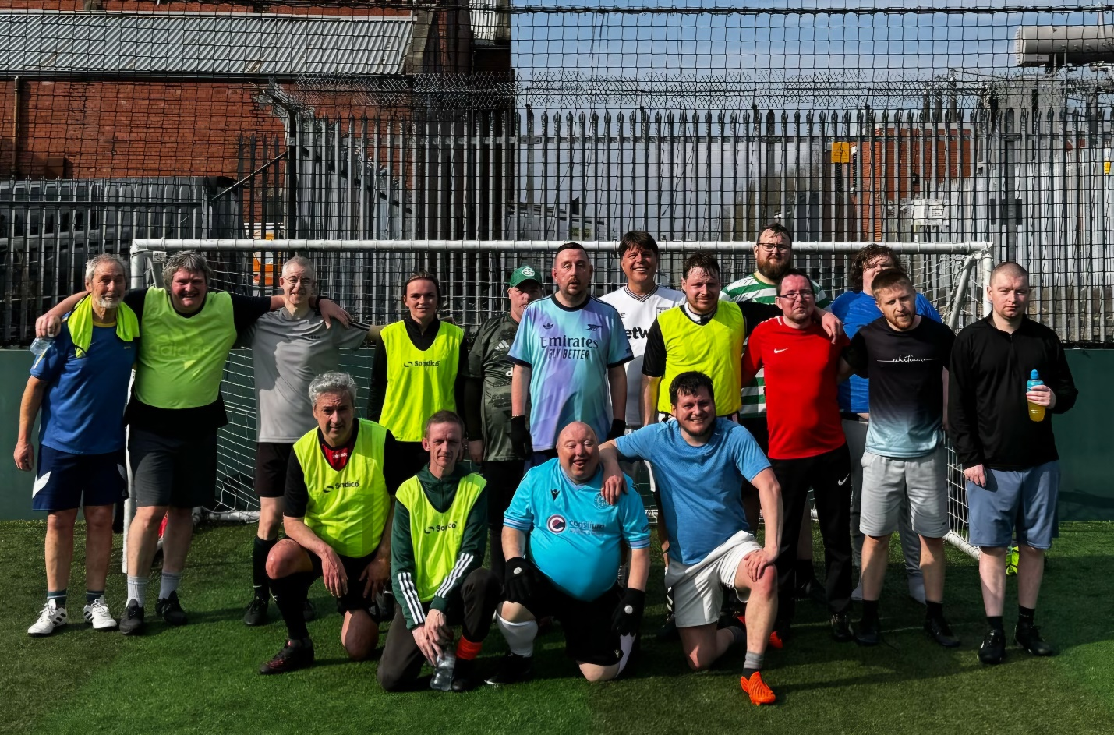

*Our CEO with our RAMH Football group March 2025*

The “What’s On?” guide includes our supports and events for the following month. If you have any comments queries or suggestions with our work, please send these to enquiries@ramh.org or phone 0141 847 8900

For more information on any of our events or if you would like this document emailed to you contact our information workers james.power@ramh.org or graham.cossar@ramh.org

# RAMH | Recovery Across Mental Health Short Breaks at Craig Tara Haven Holidays Logo, HD Png Download - kindpng

The popular coastal town of Ayr has one of Scotland’s award-winning beaches which is ideal for family days out and picnics. Holiday-makers staying at Haven's Craig Tara Holiday Park can also enjoy a fantastic beach on their doorstep! Once you’ve had one caravan holiday here, you’ll unlikely want to go anywhere else! The site is perfect for children of all ages, and couples can enjoy a memorable break away here too.

Craig Tara caravan park is also home to one of Scotland’s largest indoor swimming pool complexes.

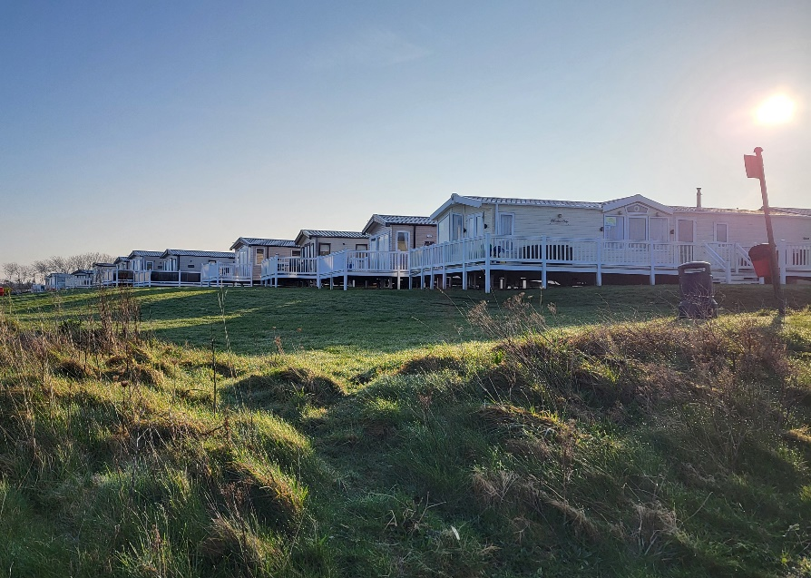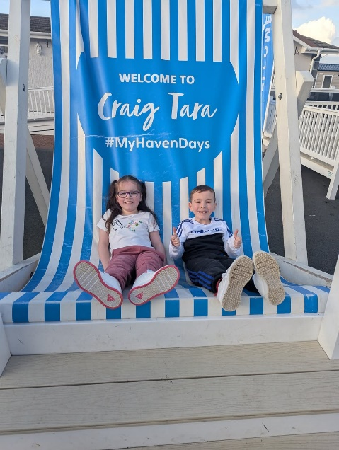

The RAMH Caravan is now **open for bookings** for stays throughout 2025.

RAMH have invested in an updated, pre-loved 6 berth caravan so service users can take advantage of a low cost and fun filled short break.

If you are interested in finding out more, please get in touch with Sandra on [Sandra@ramh.org](mailto:sandra@ramh.org) or speak to a member of staff.

# Renfrewshire

To make a referral to call 0141 404 7788 or visit ramh.org/refer or for more information please email enquiries@ramh.org

|  |  |
| --- | --- |
| **First Crisis**  Freephone: 0800 221 8929  Or Tel: 0141 848 9090 for information  Available Monday– Friday 9am- 8pm  And Saturdays and Sundays 9am-5pm | Out of hours’ crisis service which provides a short-term support to anyone in Renfrewshire aged 16 or over, experiencing a crisis in their mental health. |
| **Housing Support Services**  0141 847 8900 | RAMH Housing Support Services continues to operate 24 hours a day, every day in Renfrewshire and East Renfrewshire providing support to people in their own homes. |
| **Appointments across the week** |  |
| **1:1 Counselling** | Counselling service for adults aged over 16 in Renfrewshire who identify as experiencing challenges in their mental health. The service will continue to use a brief 6 session model (which will be reviewed at 4 sessions). This model is **suitable for mild to moderate mental health issues.** |
| **1:1 Employability Support** | Support for individuals aged 16 and over who are experiencing mental health problems to focus on improving and developing their skills and experience to improve opportunities for employment, training, or a move back into education. |
| **1:1 Anxiety Management** | Support for individuals who are struggling to control their anxiety and to help people understand why they become anxious and how their thinking affects their anxiety which in turn affects how people behave and aims to  improve their ability to control their anxiety  . |

|  |  |  |
| --- | --- | --- |
| **Mondays** |  |  |
| **Renfrew Social Hub**  Renfrew Trinity Hall  12.30–2pm |  | A mixed group of men & women who get together for Peer-to-Peer support.  We make up a six-week programme of varied activities. We are a warm welcoming group who help reduce isolation and increase your confidence |
| **Singing for Wellbeing**  Renfrew Trinity Hall  3–4.30pm |  | A warm and friendly group who like to sing and have some fun along the way. No previous experience needed just a love of music and singing along. |
| **Tuesdays** |  |  |
| **Paisley Social Hub**  Paisley Methodist Hall  6–8pm |  | Contact Plus is a mixed group of people who get together for Peer-to-Peer support and have a varied and interesting programme of activities. You will be warmly welcomed in the group. It will make you more socially connected and increase your self-esteem. |
| **Ferguslie Dye Gardeners** Sculpture House |  | Are you interested in growing dye plants and flowers? Do you want to learn about naturally dyed textiles? Would you like to meet and work within a small friendly group? Why not join the Ferguslie Dye Gardeners? Based at Sculpture House in Ferguslie Park, Paisley, the Ferguslie Dye Gardeners is a free, fortnightly workshop for Renfrewshire residents (aged 16 and over) that want to come along and grow, learn and meet people in a relaxed and informal environment. |
| **Wednesday** |  |  |
| **Wellbeing Miles**  Barshaw Park (meet at the front gate)  12.30-1.30pm |  | Walking group. Walking a mile is a great way to introduce activity to your week and connect with others. |
| **Women’s Group**  Paisley Wynd Centre  10.30am–12pm |  | A safe welcoming space for women to get peer-to-peer social support and participate in various activities over a “cuppa”. |
| **Anxiety Management Group** Paisley Wynd Centre |  | Group support for individuals who are struggling to control their anxiety. Helps them understand how their thinking affects their anxiety which in turn affects how people behave and aims to improve their ability to control their anxiety. |
| **Thursdays** |  |  |
|  |  |  |
| **Fridays** | |  |
| **1:1 Gym Support**  UWS Gym  Storrie Street | | RAMH physical activity worker supports people to be confident and competent in using the gym facility. Based centrally in Paisley at the UWS campus gym you will be given a full induction and support by the worker to develop a programme that works for you |
| **Living Life to the Full** | | A widely recognised course based on the principles of CBT (Cognitive  Behaviour Therapy). The course aims to improve wellbeing and resilience, covering how to manage low mood, stress and anxiety. |
| **Branching Out Programme**  Clydemuirshiel Lochwinnoch | | Branching Out is an outdoor therapeutic programme for adults who use mental health services in Scotland. The service consists of 3 hours of woodland activities per week for a group of 12 participants delivered over a 3-month period. |
| **Saturdays** | |  |
| **Football Group**  Power league Paisley  10.30–11.30am | | The group meets weekly for 7-aside games at the power league football Centre in Paisley. This group is for anyone wishing to participate in a fun friendly competitive game in a peer supportive setting. |

**Renfrewshire Wellbeing Map**



# East Renfrewshire

To make a referral to call 0141 881 8811 or visit ramh.org/refer or for more information please email enquiries@ramh.org

|  |  |
| --- | --- |
| **Community Link Service** | Community link workers connect people to resources and services within their local communities with the aim of improving mental and physical health and wellbeing. Speak to your GP practice in ER for more information |
| **Housing Support Service**  0141 237 0026 | RAMH Housing Support Service continues to operate 24 hours a day, every day in East Renfrewshire providing support to people in their own homes |
| **Causeway Newsletter** Next issue 30th April | Causeway newsletter gives an overview of group experiences and current supports. The newsletter is compiled by our information peer volunteer and emailed out to all active clients with email permissions |
| **RAMH Community Garden**  21 Carlibar Road, Barrhead  ***Garden Group returns this month!*** | Our garden is equipped with a number of things to help you be mindful and connect with nature. We have mindfulness cards, positivity quotes, a bug hotel, heather and rose beds, 4 raised beds and ample seating. Open to everyone to use as they wish. |
| **Appointments across the week** |  |
| **1:1 Counselling** | Up to six sessions for people who experience mild to moderate depression  and anxiety. Focus is on self  management skills, using self-management NHS workbooks and  signposting to other services where appropriate. |
| **1:1 Anxiety Management** | Support for individuals who are struggling to control their anxiety and to help people understand why they become anxious and how their thinking affects their anxiety which in turn affects how people behave and aims to  improve their ability to control anxiety. |
| **Living Life to the Full**  23rd,25th 30th April 1st May  Mearns Library | A widely recognised course based on the principles of CBT (Cognitive  Behaviour Therapy). The course aims to improve wellbeing and resilience, covering how to manage low mood, stress and anxiety. |

|  |  |  |  |
| --- | --- | --- | --- |
| **Mondays** | |  |  |
| **Men Do Talk**  Dunterlie Resource Centre  10am–12pm | |  | A men’s’ peer led support group providing support and discussing issues that impact on mental health and wellbeing. |
| **Time 2 Talk**  Auchenbach Resource Centre  11am–1pm | |  | A peer led recovery focused discussion group. A chance to discuss issues that are affecting your mental health and wellbeing. |
| **Wellbeing Miles**  Rouken Glen Park Eastwood  1–2pm | |  | Walking group. Walking a mile is a great way to introduce activity to your week and connect with others. We walk at the groups pace and talk as we go. If you want to add some light supported physical activity to your week come and join us for a walk |
| **Tuesdays** | |  |  |
| **Swimming Group**  Barrhead Pool  10am | **(Peer-led)** |  | Using swimming to help increase activity, the group is supported by physical activity worker who is also in the water to give those attending motivation and confidence to participate with this hugely beneficial activity. A basic level of competency in the water is expected from those who attend. |
|  |
| **Mindful Movement**  Barrhead Centre  5.15-6.30pm | |  | Our new *“Mindful Movement”* class is a combination of chair based exercise and mindful exercise looking to relax and strengthen you both mentally and physically, the sessions allow you to work at your own pace and build fitness and confidence. |
| **Link Club**  Dalmeny Resource Centre  1–3pm | |  | Weekly social connections group for people living in East Renfrewshire |
| **Wednesdays** | |  |  |
| “Where the wild things go”  Nature Walk Dams to Darnley  12.30pm  (meeting Darnley Mill  Car Park)  **Peer led** | |  | This walk helps you connect closer with nature, walking within the scenic Dams to Darnley Country park. This will be a longer walk both in distance and duration than the rest of the wellbeing miles’ programme. However the group does take stops and rests along the way. |
| **Branching out**  Whitelee Windfarm  11am-2pm | |  | Branching Out is an outdoor therapeutic programme for adults who use mental health services in Scotland. The service consists of 3 hours of woodland activities per week for a group of 12 participants delivered over a 3-month period. |
| **Thursday** | |  |  |
| **Social Support Group**  Clarkston Halls  1.30–3.30pm | |  | This group meets weekly and supports people to make new social connections within their community and reduce isolation. |
| **Fridays** | | |  |
| **Wellbeing Miles**  Fairweather Park Newton Mearns 1–2pm | | | Walking group. Walking a mile is a great way to introduce activity to your week and connect with others. |
| **Saturdays** | | |  |
| **Football Group**  Power league Paisley  10.30–11.30am | | | The group meets weekly for 7-aside games at the power league football Centre in Paisley. This group is for anyone wishing to participate in a fun friendly competitive game in a peer supportive setting. |

**East Renfrewshire Wellbeing Map**



# North Ayrshire Recovery College

Our Recovery College in North Ayrshire is all about self-management for mental health, learning together, with a strengths based approach, to build individual’s wellbeing and recovery.

We hold information sessions for anyone who is interested in finding out more about the Recovery College. These sessions are appropriate for those who may be interested in joining the Recovery College as a student or for those who may refer into the service.

Anyone who is 16+ and lives, works or studies in North Ayrshire can become a student at the Recovery College. At these sessions, you will meet some of the Recovery College Team, Hear Peer Volunteers Recovery Stories and get more information on the courses we offer.

Visit [ramh.org/north-ayrshire-wellbeing-recovery-college/](https://ramh.org/north-ayrshire-wellbeing-recovery-college/) to find out more.

# Helplines

If you live in Renfrewshire, contact FIRST Crisis on free phone 0800 221 8929 (or standard rate 0141 848 9090).

We are available 7 days a week, 365 days a year, Monday-Friday 9am-8pm and Saturday & Sunday 9am-5pm.

If you live outside Renfrewshire and need immediate help, contact:

* **Breathing Space**: 0800 83 85 87 [www.breathingspace.scot](http://www.breathingspace.scot/)
* **Samaritans**: 116 123 [www.samaritans.org](http://www.samaritans.org/)
* **NHS 24**: 111 [www.nhs24.com](http://www.nhs24.com/)
* **Text SHOUT** to 85258 [www.giveusashout.org](http://www.giveusashout.org/)